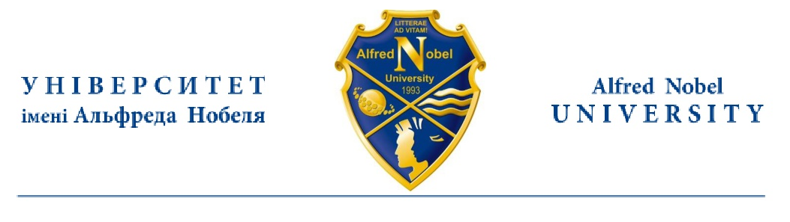

CERTIFICATE

Is given to _________, the student of Alfred Nobel University, the Department of the ____________, to certify that her level of English skills equals the European standard B2 and she has passed her examination in English with grade B2 – excellent (85 grade).

Name Surname
PhD, A/Professor

Department of the ___________
Alfred Nobel University

