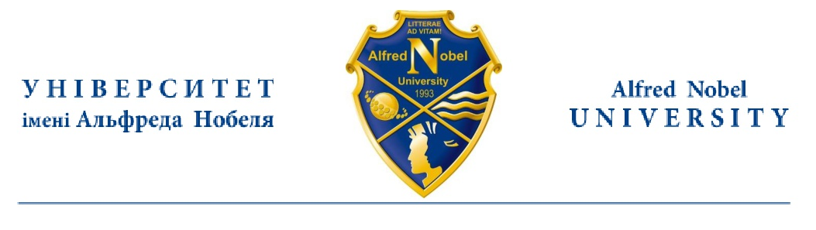

CERTIFICATE

Is given to (insert your name and surname)____________, the student of Alfred Nobel University, (indicate the Department you study at) ________________, to certify that her level of English skills equals the European standard B1 and she has passed her examination in (indicate language) ____________ with grade ________________ (indicate grade and points).

Name Surname
PhD, A/Professor

Department___________
Alfred Nobel University

